**PERSHING MURAL PROJECT CURRICULUM**

**Learning From the Past, Understanding the Present,**

**and Discovering the Future**

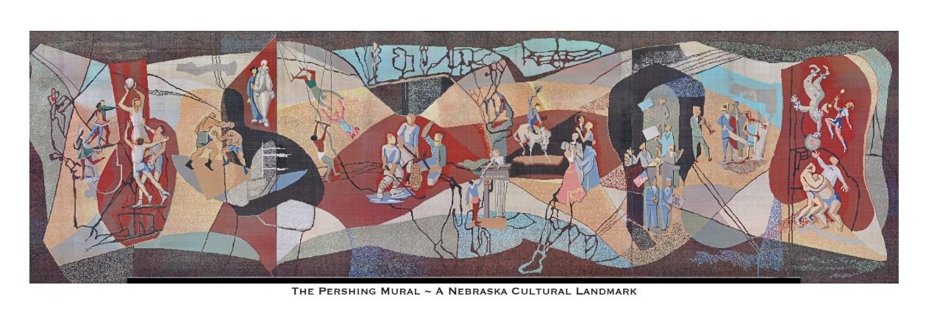

**General John J. Pershing**

*The Pershing Auditorium and its Mural bear the name of General John J. Pershing, the most highly decorated military officer in United States history. Pershing’s strong connection to the city of Lincoln played a major part in the naming of the building and Mural. At the conclusion of the lesson, students are invited to write a speech about Pershing that could have been delivered at the Auditorium’s dedication in 1957.*

*Note: This lesson is geared to the sixth-grade level and provides a brief biography of Pershing’s life; it is meant to get students excited about history. At a higher grade level, there could be more in depth, higher-level discussion about U.S. policies during this time in our Nation’s history and we leave that teachers to explore with their students.*

**Included in Lesson:**

* General John J. Pershing Lesson Plan
* Power Point General John J. Pershing

**Nebraska Standards Addressed:**

Present: SS 1.4.1.a List and describe life events over time.

Respond: SS 6.4.3.a Identify how differing experiences can lead to the development of perspectives.

Respond: L.A.5.W.2 Use a recursive writing process to develop, strengthen, and produce writing appropriate to the audience

Create: EP6. Use English structures to communicate context-specific messages.

Connect: SS 6.4.2 Use multiple perspectives to identify the historical, social, and cultural context of past and current events.

Connect: SS 7.4.5.c Gather, analyze, and communicate historical information about the world from multiple sources.

**Objectives:**

* After the students have studied the life and career of General John J. Pershing, they will be able to list at least four his accomplishments.
* The students will be able to describe the characteristics and traits of Pershing that made him a successful teacher and leader.
* The student will be able to write two to three paragraphs about the life of Pershing that could be used in a dedication speech.

**Grade Level:**

Written at 6th Grade Level (educators are encouraged to adjust the lesson to meet needs of Pre-K to 12th Grade)

**Materials Needed:**

Paper, pens/pencils

**Time Requirement:**

1-2 (50 minute) sessions

**Vocabulary:**

Dough Boy: Nickname given to U.S. soldiers during WWI.

Rough Rider: A member of the first U.S. Volunteer Calvary regiment in the Spanish-American War commanded by Theodore Roosevelt.

Buffalo Soldier: Black Calvary Troops—American Plains Indians who fought against these soldiers referred to the black cavalry troops as “buffalo soldiers” because of their dark, curly hair which resembled a buffalo’s coat and because of their fierce nature of fighting.

Cadet: A young person undergoing preliminary training, usually before full entry to the uniformed services (military, police, etc.).

Silver Star: A US military award that is given to a soldier who is extremely brave in battle.

Pulitzer Prize: An award for an achievement in American journalism, literature, or music—there are thirteen made each year.

**Direct Instruction:**

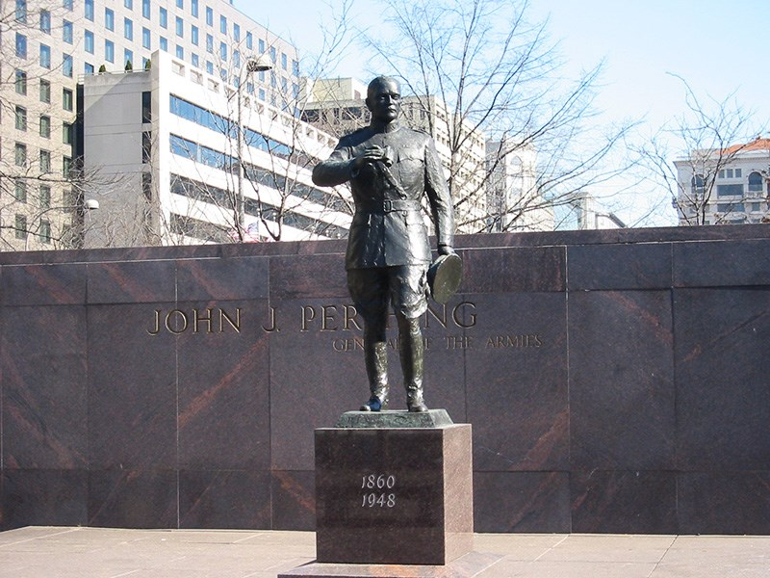

Pershing Park on Pennsylvania Avenue NW, Washington, DC.

*“His name must be known by all Americans—every veteran, every school child. We are the generation that will ensure his name is firmly planted in the hearts, minds, and history of our country. The Pershing name must not be lost to history.”—*Dwight Eisenhower

John J. Pershing (1860-1948) was born into humble beginnings in Laclede, Missouri. Through his decorated military career, Pershing became General of Armies (a rank created specifically for him), which made him the highest-ranking living active-duty officer in American military history. Only General George Washington, who was promoted to this rank in 1977 (177 years after his death), has shared this same, highest rank.

Students can be encouraged to understand that an exciting part of the work of history and historical interpretation is that over time, understanding and interpretation of the past may shift and change. Different people in different times may understand things in other ways. This is an important consideration when addressing this lesson since Pershing lived more than 100 years ago. With that in mind, here is an abbreviated history of life of General John J. Pershing:

* When Pershing was still in his teens, his first job was as a school teacher at Prairie Mount School in Chariton County, Missouri where he taught black students.
* By saving money from his teaching job, he was able to attend school in the summer months and Pershing received his A.B. Degree from Kirkville Normal School in Northern Missouri.
* When Pershing saw an ad for West Point, seeking “honest, strong, God-fearing boys,” he applied and passed his entrance exam, joining the Academy in 1882. He graduated in 1886, 30th in a class of 77.
* His first post after graduating from the Academy was at Fort Bayard, New Mexico where he became a First Lieutenant commanding a unit of black calvary, aka the buffalo soldiers.
* Pershing’s nickname was “Black Jack” Pershing. One theory for the origin of the name is that it came from commanding the Buffalo Soldiers. Another theory is it was an old army term for a punishment detail since Pershing could be a strict disciplinarian.
* From 1891 to 1895 Pershing continued his career and education in Nebraska (see below).
* He returned to West Point in 1897 as an instructor before being assigned to Cuba.
* During the 1898 Spanish American War, he fought alongside Theodore Roosevelt and his “Rough Riders.” Pershing earned the Silver Star for this service and was promoted to the rank of Captain.
* For much of the early 1900’s, Pershing served in the Philippines where he commanded U.S. troops and was the military governor of the southern Philippines.
* In 1904, President Theodore Roosevelt appointment him as a brigadier general ahead of 862 other officers who had more seniority.
* In 1914 Pershing was sent to the Mexican border where he was charged with squashing attacks on Americans.
* In 1915, Pershing’s wife Frances and three daughters died in a tragic house fire; his son Warren survived.
* In April, 1917, with the entrance of the U.S. into World War I, Pershing was promoted to a Major General and became the commander of the AEF (American Expeditionary Forces).
* It was Pershing’s task to build and prepare the small and inexperienced U.S. peace-time military (220,000 soldiers and officers) for war. Pershing helped train and transform the troops which grew to more than two million “doughboys”.
* By mid-1918, the German government was faced with 2 million American soldiers among the allied ranks under the command of General Pershing with 2 million more on the way. Germany surrendered on November 11, 1918, and the war was ended.
* After WWI, Pershing was promoted to General of the Armies, the highest-ranking military officer in history.
* In 1932 Pershing won the Pulitzer Prize for history for his two-volume book set, “My Experiences in the World War.”
* Pershing was a mentor to a generation of U.S. Army generals including George S. Patton, Dwight D. Eisenhower, George C. Marshall, and Omar Bradley.

**General Pershing’s Nebraska Connection:**

Before arriving at the University of Nebraska, Pershing, a young lieutenant, served in New Mexico in the U.S. Army’s 6th Calvary. He was tasked with trying to keep the peace between settlers and Native tribes who resided there. After five years on the American frontier, he was disheartened by the circumstances facing the Native Americans and felt sympathy for them because of their mistreatment.

At a time of national peace and with much to mull over, Pershing was reexamining his military career prospects when in 1891 he was assigned to the University of Nebraska. His commission was to lead the cadet training program and teach classes in math and military tactics. This gave him the perfect opportunity to take time to re-evaluate his career path and even pursue his studies in Law.

While earning his law degree, Pershing taught math class at the University of Nebraska every school day for three hours. It was said by his students that he taught more like a military general than a professor. Among his students were future authors Willa Cather and Dorothy Canfield. (When he made his 1932 acceptance speech for his Pulitzer Prize, he made a light-hearted reference to his former student Willa Cather who won the Pulitzer Prize ahead of him in 1923.)

While at the University, it was Pershing’s task to transform the cadets in the training program into a disciplined, efficient drill company. When Pershing started this assignment, he found a faculty and administration ambivalent to the cadet program and just 90 lackluster students who did not take the training seriously. Pershing was able to win over the cadets by instilling discipline and pride in the corps. Within a year, the university cadet corps swelled to 350 students and pride for the program grew at the school.

In 1892, a national military drill competition was held in Omaha and through discipline, pride and hard work, Pershing’s Cadets took top honors in their division!

[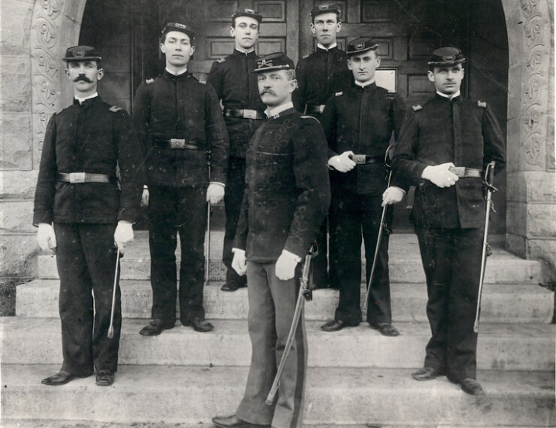](https://news.unl.edu/sites/default/files/media/Pershing%201892%20Great%20Photo%20at%20UNL%20with%20staff.jpg)

Years later, in honor of their former cadet corps commander, the University of Nebraska military drill team renamed itself “Pershing’s Rifles” and units of its kind still flourish across the country as a lasting tribute to Pershing’s legacy. (A presentation by Pershing’s Rifles was part of the dedication ceremony of the Pershing Auditorium in 1957.)

By 1895, Pershing finished his studies, received his law degree, and recommitted himself to the military, going on to build his historic career through his service to his country. Despite his rise in fame, accomplishments, and stature, his friendships and bonds with the Lincoln community would last. He would call Lincoln his second home and would frequently return to Lincoln when his duties from around the nation allowed, visiting his sisters in a home Pershing owned on 17th and B Streets.

For a glimpse into the life of John J. Pershing, visit YouTube <https://www.youtube.com/watch?v=Ru3DzGSwdeE> to see a documentary, “Black Jack Pershing: Love and War” created by University of Nebraska-Lincoln Journalism Professor Barney McCoy. Special thanks to Professor McCoy for sharing his research and insights into the life of General Pershing that make this lesson possible. Also check out the PBS Learning Link Professor McCoy produced about the life of John J. Pershing:

<https://nebraskapublicmedia.pbslearningmedia.org/collection/black-jack-pershing-love-and-war/>

In 1939, Lincoln approved a plan to build a civic auditorium for the city. The high school students in Lincoln were tasked with coming up with an appropriate name for the building. These students decided to name the building the Pershing Auditorium in honor of General John J. Pershing. However, given the depression and onset of WWII, design and construction of the Auditorium was delayed until the 1950’s. The name chosen for the building was never changed and remained the Pershing Auditorium.

**Discussion Questions:**

* Pershing graduated 30th out of a class of 77 from West Point—he was not top of his class even though he went on to become one of the most decorated military officers in U.S. history. Does that teach you any lessons?
* What do you think Pershing might have learned from being in the military in different parts of the world and commanding various units?
* What was it about Pershing that made him so successful, respected and honored? What traits or characteristics did he possess that led to his success?
* When Pershing came to the University of Nebraska to teach and study, he was thinking about leaving the military and going into law. How do you think our world would have been different if he had done that and not gone on to lead the allies in WWI? Can one person make a big difference in the country? In the world?
* Why do you think Pershing called Lincoln his “Second Home?”
* Why do you think students in 1939 settled on the Pershing Auditorium as the name for the building?
* What can we learn from General Pershing today?

**Guided and Independent Practice:**

On March 10, 1957, there was a big Pershing Municipal Auditorium dedication ceremony. Committees comprised of more than 100 people were responsible for organizing the event to create something very special to commemorate this monumental day when the doors of the Auditorium would be opened. Souvenir keepsake brochures were printed, decorations festooned the proceedings, tours were planned and publicity was used to invite the public to the grand affair. Every aspect of the dedication was planned to the minute and the program included music (organ, vocal and symphonic), presentation of colors and Pershing’s Rifles, presentation of distinguished guests, an address by the Chief Justice of the Nebraska Supreme Court, a prayer of dedication, and the presentation of the Auditorium key to Mayor Bennett S. Martin.

Your assignment is to go back into time to February, 1957, a few weeks prior to the dedication. You are to imagine that you are an aid and occasional speech writer for Mayor Martin. His contribution to the program is to accept the keys to the auditorium and give a ten-minute speech. He already has his introduction and closing written but he is struggling with the body of the speech—what to say about General John J. Pershing and why his name will forever be associated with this building and mural.

1. Your job as speech writer is to provide two or three paragraphs about General John J. Pershing that Mayor Martin can include in his speech.
2. Your writing should include information that is historic as well as inspirational. It should include references to Pershing’s connection to Lincoln.
3. Don’t just write about facts—write about feelings, traits and the qualities Pershing possessed that made him who he was.
4. Each paragraph should be four to five sentences long and use correct grammar, punctuation, and spelling.
5. You have already been given a lot of information about General Pershing, but do not be afraid to dig a bit deeper on your own to find any additional “nuggets” you can use in your writing.
6. Once you have written a draft of the speech, read it aloud to see if it flows. Share it with a classmate for critique.
7. Edit and rewrite.

**Evaluation:**

The students will be evaluated on:

1. Their creativity
2. Their use of the facts and history presented
3. The fluidity of their “speech”
4. Use of correct grammar, spelling, and punctuation

**Closure:**

Even though General John J. Pershing may not be a common name to this generation in the 21st century, there is still much that can be learned from his life and legacy. Much of his fame rests on his personal character, his will for victory, and his belief in his military. Times may change, but the tough determination, hard work, discipline, and character it takes to be successful have not.

**Resources:**

National Parks <https://www.nps.gov/articles/general-john-j-pershing.htm#:~:text=Pershing%20graduated%20in%201886%2C%2030th,of%20%E2%80%9CBlack%20Jack%E2%80%9D%20Pershing> *Public Domain*

N Nebraska Today <https://news.unl.edu/newsrooms/today/article/nebraskas-connection-to-gen-john-j-pershing/> *Special thanks to Dr. Barney McCoy of the University of Nebraska-Lincoln for giving permission to use the content of their website in this lesson plan (3-8-24).*

N Nebraska Today <https://news.unl.edu/newsrooms/today/article/11-things-you-probably-didnt-know-about-john-j-pershing/> *Special thanks to Dr. Barney McCoy of the University of Nebraska-Lincoln for giving permission to use the content of their website in this lesson plan (3-8-24).*

History Nebraska <https://www.nshsf.org/wp-content/uploads/2022/06/725.83-P466m-Pershing-Municipal-Auditorium.pdf> *Public Domain*

********

Special thanks to the Pershing Mural Curriculum Committee:

Liz Shea-McCoy, Bob Reeker, and Anne Woita

This lesson has been supported by a grant from:

 and the 

And was made possible by the:

Pershing Mural Historic Preservation Project

